**Soil Health Monitoring System**

**An Engineering Project in Community Service**

***Submitted by***

***Ankit Maurya 21BEC10043***

# 

***in partial fulfillment of the requirements for the degree of Bachlore of Engineering and Technology***



**VIT Bhopal University**

**Bhopal**

**Madhya pradhesh**

## March, 2024

**Declaration of Originality**

We, hereby declare that this report entitled **“ Soil Nutrient Testing System”** represents our original work carried out for the EPICS project as a student of VIT Bhopal University and, to the best of our knowledge, it contains no material previously published or written by another person, nor any material presented for the award of any other degree or diploma of VIT Bhopal University or any other institution. Works of other authors cited in this report have been duly acknowledged under the section ''References''.

|  |  |  |
| --- | --- | --- |
|  |  |  |

**Acknowledgement**

We extend our deepest gratitude to all those who contributed to the realization of this project, directly or indirectly.

First and foremost, we would like to express our sincere appreciation to [Supervisor/Mentor's Name], whose guidance, expertise, and unwavering support were instrumental throughout every stage of this endeavor. Their valuable insights and encouragement propelled us forward, shaping the direction of our research and development efforts.

We are immensely thankful to the [University/Institution's Name] for providing us with the necessary resources, facilities, and funding to pursue this project. Their commitment to fostering innovation and academic excellence has been integral to our success.

We also wish to acknowledge the contributions of our fellow team members, whose dedication, collaboration, and collective efforts were essential in overcoming challenges and achieving our objectives. Each member brought unique skills and perspectives to the project, enriching our collaborative process and contributing to its overall success.

Furthermore, we would like to express our appreciation to the farmers and agricultural experts who generously shared their knowledge, experiences, and feedback, enriching our understanding of real-world agricultural practices and challenges.

Last but not least, we extend our heartfelt thanks to our families, friends, and loved ones for their unwavering support, understanding, and encouragement throughout this journey.

This project would not have been possible without the invaluable contributions of each individual and organization mentioned above. We are deeply grateful for their support and collaboration.

**Abstract**

This project introduces an innovative approach to agricultural management through the development and implementation of an Integrated IoT-Based Soil Health Monitoring System. The system is designed to address the critical need for real-time monitoring and analysis of soil conditions to optimize crop productivity while promoting resource efficiency and environmental sustainability.

Key objectives include the seamless integration of sensors, such as NPK and humidity sensors, to accurately measure soil mineral levels and humidity conditions. Real-time data collection is enabled through a robust mechanism, ensuring uninterrupted monitoring of soil conditions. Utilizing cutting-edge IoT technology, the system wirelessly transmits collected data to a centralized database, facilitating further analysis and decision-making.

A user-friendly web application serves as the interface for farmers, allowing effortless access and analysis of soil mineral data. Unique features include the ability to specify crop types for customized analysis, comparison with standard crop requirements, and generation of actionable insights regarding soil mineral levels.

Empowering farmers with precise analysis, the system facilitates data-driven decision-making in fertilization and soil management, thereby promoting resource conservation and minimizing environmental impact. Scalability and compatibility are ensured to accommodate various farm sizes and crop types.

Rigorous testing validates the reliability and accuracy of sensor readings, data transmission, and analysis performed by the system. By achieving these objectives, the IoT-Based Soil Health Monitoring System aims to revolutionize agricultural practices, providing farmers with valuable insights to optimize resource usage and enhance crop productivity.

INDEX

1. Introduction 3
   1. Motivation 4
   2. Objective 4
2. Literature Review 5
3. Topic of Work 9
   1. System Design 9
   2. Working Principle 11
   3. Results and Discussion 12
4. Conclusion 17
5. Reference 18

BIODATA 21

LIST OF FIGURES

|  |  |  |
| --- | --- | --- |
| **Sr.no** | **Caption** | **Page no.** |
| Fig 1 | SYSTEM DESIGN | 9 |
| Fig 2 | RECIEVER CIRCUIT | 10 |
| Fig 3 | TRANSMITTER CIRCUIT | 10 |
| Fig 4 | FLOWCHART | 11 |
| Fig 5 | PCB CIRCUIT DIAGRAM | 12 |
| Fig 6 | PCB SCHEMATIC | 13 |
| Fig 7 | PCB DESIGN | 13 |
| Fig 8 | CAD MODEL | 15 |
| Table 1 | INDIVIDUAL CONTRIVUTION | 16 |

# INTRODUCTION

In the heartland of Indian agriculture, where traditions meet technological advancements, our project emerges as a beacon of innovation—a homegrown IoT-based Soil health monitoring system designed to revolutionize the way Indian farmers cultivate their land.

India's agricultural tapestry, woven by millions of dedicated farmers, faces unique challenges from varying soil conditions to the need for resource-efficient farming practices. Recognizing these challenges, our project integrates the power of the Internet of Things (IoT) to offer a solution tailored to the specific needs of Indian agriculture. In a country where agriculture is not just an occupation but a way of life, the significance of precision and efficiency in farming practices cannot be overstated.

From the vibrant fields of Punjab to the arid landscapes of Rajasthan, the soil mineral data collected by our array of sensors, including region-specific considerations like nitrogen, phosphorus, potassium (NPK), and humidity sensors, promises accurate insights into the unique needs of Indian crops. The circuit diagrams and sensor codes are tailored to the nuances of Indian agriculture, ensuring practicality and relevance.

In the following pages, we delve into the intricacies of our IoT-based Soil health monitoring system, keeping in mind the context of Indian agriculture. From the details of the hardware architecture to the coding that governs data collection, every element of this project is a testament to our commitment to addressing the needs of Indian farmers. Together, we aim to usher in a new era where technology harmonizes with tradition, empowering farmers across India with the tools they need for sustainable and prosperous agriculture

## Motivation

Witnessing the challenges faced by Indian farmers—ranging from unpredictable weather patterns to the need for judicious resource utilization—we recognized the potential of technology to be a transformative force. The motivation stems from a desire to empower farmers, the backbone of our nation, with tools that can enhance their decision-making capabilities, increase efficiency, and contribute to the sustainability of Indian agriculture. In a country where agriculture is not merely an industry but a way of life, our motivation is fuelled by the vision of a future where technology harmoniously integrates with tradition, elevating Indian farming practices to new heights of productivity and prosperity. This project embodies a commitment to making a tangible difference in the lives of farmers across India, reflecting our dedication to a brighter, technologically enriched future for Indian agriculture.

## Objective

**1. Develop an Integrated IoT-Based Soil Health Monitoring System:**

* Design and implement a comprehensive system that seamlessly integrates sensors, including NPK and humidity sensors, to accurately measure soil mineral levels and humidity conditions.

**2.Enable Continuous Real-time Data Collection:**

* Establish a robust mechanism for the sensors to collect real-time data from the soil, ensuring continuous and uninterrupted monitoring of soil conditions.

**3. Implement Efficient Wireless Data Transmission:**

* Utilize cutting-edge IoT technology to wirelessly transmit collected data to a centralized database or server, facilitating further analysis and decision-making.

**4. Create an Intuitive Web Application:**

- Develop a user-friendly web application that serves as an accessible interface for farmers to effortlessly access and analyze soil mineral data.

**5. Incorporate Crop Selection Feature:**

- Integrate a feature within the web application allowing users to specify the type of crop they are cultivating, enabling customized analysis based on the unique requirements of each crop.

**6. Establish Comparison with Standard Crop Requirements:**

- Implement intelligent algorithms within the web application to compare real-time soil mineral data with recommended levels for the selected crop.

**7. Generate Actionable Insights:**

**-** Present clear indications, through actionable insights, regarding whether soil minerals are within the optimal range, deficient, or excessive for the chosen crop**.**

**8. Empower Data-Driven Decision-Making:**

- Empower farmers to make informed decisions about fertilization and soil management based on the precise analysis provided by the system.

**9. Promote Resource Efficiency:**

- Contribute to resource conservation by assisting farmers in optimizing fertilizer use, thereby reducing unnecessary expenses and minimizing environmental impact.

**10. Ensure Scalability and Compatibility:**

- Design the system to be scalable for various farm sizes and compatible with a diverse range of crops, ensuring broad applicability across different agricultural settings.

**11. Enhance User Interface and Experience:**

- Prioritize the development of a user-friendly interface for the web application, ensuring accessibility for users with varying levels of technological expertise.

**12. Evaluate System Reliability and Accuracy:**

- Conduct rigorous testing to ensure the reliability and accuracy of sensor readings, data transmission, and analysis performed by the system.

By achieving these objectives, the IoT-Based Soil Health Monitoring System aims to revolutionize agricultural practices, providing farmers with valuable insights to optimize resource usage and enhance crop productivity.

# Literature Review

An IoT-based smart soil monitoring system designed by [1] N. Ananthi for agriculture in India integrates pH, temperature, and humidity sensors to transmit real-time soil data via Wi-Fi to a mobile app. This aids farmers in crop selection and supports automated irrigation, aligning with our project's focus on IoT-based soil mineral detection. Furthermore, the system incorporates crop images for pest management, enhancing its relevance to our objectives.

Sandeep V. Gaikwad et al. [2] presented an innovative IoT-based precision farming system in Computers and Electronics in Agriculture. Their system, employing an Arduino-based IoT device, monitors real-time parameters like soil moisture, temperature, and air humidity at the agro-field level. Comprising a smartphone application and a cloud server, this cost-effective solution enables efficient data collection and analysis. The research resonates with our project's focus on real-time monitoring, offering valuable insights into integrating IoT devices for precision agriculture.

Bekele M. Zerihun et al [3] proposed an IoT-based monitoring system utilizing LoRaWAN and ThingSpeak for remote field monitoring in [3,6]. This system employs low-cost IoT sensor nodes to gather real-time data on environmental parameters. Data transmission via LoRaWAN to a central control station through ThingSpeak allows for real-time data aggregation and visualization, aiding informed decision-making in agricultural management.

The proposed IoT system in [4,5,15] integrates various sensors for pH, humidity, temperature, soil moisture, and soil nutrients (NPK), along with a microcontroller equipped with WiFi for data transmission to the cloud. The system employs SVM and Decision Tree algorithms for a recommending system, suggesting suitable crops based on soil data to enhance growth through optimized farming processes.

Traditional methods for land cover and crop classification using remote sensing data are being challenged by This paper [7] Kussul N et al .A Deep Learning Classification of Land Cover and Crop Types Using Remote Sensing Data proposes a multilevel DL architecture that incorporates unsupervised neural networks for data preprocessing and multiple supervised neural network approaches for classification. The study shows that using an ensemble of convolutional neural networks (CNNs) achieves higher accuracy in classifying crop types, particularly summer crops like maize and soybeans, compared to traditional methods like multilayer perceptrons (MLPs) and random forests.

The paper by [8] Dagar, Som, and Khatri explores the concept of smart farming, which integrates information technology like sensors and networks into farm management. They highlight the role of the Internet of Things (IoT) and cloud computing in this transformation, along with the potential for robotics and artificial intelligence. While acknowledging the potential disruption to traditional practices, the authors discuss the tools and applications of wireless sensors in IoT agriculture across the entire farming cycle, from planting to harvest, including packaging and transportation. They also identify challenges associated with merging these technologies with conventional farming methods.

The paper by [9] Hu, Zhong, and Xu reviews smart irrigation systems in the context of water scarcity and agriculture. With a growing focus on water conservation, the authors explore the use of sensor-based systems for irrigation management. They acknowledge the cost challenges for smaller farmers but highlight the development of more affordable sensors and integration with IoT and WSN technologies. The paper examines the key parameters monitored in irrigation systems, including water quantity/quality, soil characteristics, and weather. Finally, it discusses the technological considerations and best practices for implementing these sensor-based systems.

Traditionally, soil analysis for nutrients (NPK) is performed in labs, which can be time-consuming and deter farmers from regular testing. This paper [10] by Madhumathi R. , Arumuganathan T and Shruthi R, proposes a Wireless Sensor Network (WSN) based system for precision agriculture. The WSN monitors soil fertility (NPK), moisture, pH, and temperature. This data is transmitted to the cloud and displayed on a mobile app. The system leverages the Internet of Things (IoT) to recommend optimal water and fertilizer application, promoting improved soil health and crop growth.

The rise of climate change, land degradation, and resource limitations necessitates advancements in agricultural practices. Precision agriculture offers a solution by using sensors and information technology to optimize resource use and improve productivity. This paper by [11] Sangeetha et al. exemplifies this approach, proposing an IoT-based system for precision agriculture monitoring. Such systems address the challenge of large-scale monitoring by collecting data on crop health and growth indicators, paving the way for data-driven decision making in farm management.

The paper [12,20] highlights the importance of crop production in India and the challenges of fertilizer use. They propose a system using the Internet of Things (IoT) and Machine Learning (ML) for soil testing. Sensors for factors like temperature, moisture, pH, and NPK levels collect data that is then analyzed by ML algorithms like random forests. This analysis helps recommend suitable crops based on the soil conditions. The system additionally explores using Convolutional Neural Networks (CNNs) to identify potential plant diseases.

Gupta et al. Emphasize the significance of agriculture for both food security and economic well-being. Traditionally, crop yield prediction relied on less accurate methods. This paper [13,15] highlights the importance of machine learning (ML) in modern agriculture. ML can predict crop yields based on various factors like weather, soil conditions, and historical data. This allows farmers and policymakers to make informed decisions about crops, resources, and market strategies. The study proposes an ML framework for crop yield prediction that incorporates feature selection and utilizes algorithms like PSO-SVM, K-nearest neighbor, and random forest for improved yield estimation.

Soil testing is crucial for optimizing fertilizer use and maintaining soil health. This study by [14] Suchithra and Pai explores Extreme Learning Machines (ELMs) for classifying various soil properties like phosphorus, potassium, organic carbon, boron content, and pH. By analyzing soil test data, ELMs can help categorize these parameters at the village level. This research suggests that ELMs with appropriate activation functions can be a valuable tool for soil analysis.

The paper [16] by Balakrishnan and Muthukumarasamy (2016) delves into the application of ensemble machine learning models for crop production prediction. While traditional methods such as time series analysis have been commonly employed for agricultural forecasting, this study concentrates on Support Vector Machines (SVM) and Naive Bayes classifiers. The authors introduce ensemble models, AdaSVM, and AdaNaive, which integrate these techniques and evaluate them against standalone models. Their findings suggest that the ensemble models outperform SVM and Naive Bayes alone, achieving higher accuracy in crop production prediction.

The paper by [17] Sivakumar et al. (2022) emphasizes the critical role of agriculture in India's economy. They argue that agriculture and irrigation are fundamental sectors and that Information and Communication Technology (ICT) is essential for improvement throughout the agricultural cycle. Machine Learning (ML) and the Internet of Things (IoT) are identified as key advancements that can automate and optimize various agricultural practices.

Kulkarni et al, in the paper [18], developed a crop recommendation system to address low crop productivity caused by poor crop selection. Their system utilizes ensemble machine learning techniques, combining predictions from models like Random Forest, Naive Bayes, and Linear SVM. By analyzing soil and climatic data, it recommends suitable crops (Kharif or Rabi) for specific land areas. With an impressive average classification accuracy of 99.91%, this approach shows promise for improving crop selection and boosting agricultural productivity.

The paper by [19]Akhter and Sofi highlighted the transformation of agriculture towards data-driven precision farming practices. The emergence of the Internet of Things (IoT) has revolutionized various sectors, and agriculture is no exception. This paper explores how Machine Learning (ML) combined with IoT data analytics can significantly improve agricultural outcomes.The benefits include increased crop yields, improved quality, and better resource management. These advancements are fundamentally changing traditional farming methods and creating new opportunities. However, the paper acknowledges challenges associated with integrating these technologies into conventional practices. Finally, the study proposes a disease prediction model for apple orchards using an IoT system with data analytics and ML, showcasing a practical application of these advancements.

Ashifuddin Mondal et al ,in the paper [20] explores the use of Deep Neural Networks (DNNs) for crop yield prediction in their research published in Frontiers in Plant Science. Accurately predicting crop yields is complex due to various influencing factors like genetics, environment, and their interactions. Traditionally, such predictions require extensive data and powerful algorithms.

Khaki, S.; Wang, L. in the paper [21] designed a DNN model that achieved superior accuracy in yield prediction compared to other methods like Lasso, shallow neural networks, and regression trees. Their model achieved a Root Mean Squared Error (RMSE) of 12% of the average yield, demonstrating its effectiveness.

The paper by [22] Viviliya and Vaidhehi investigated the applications of Big Data (BD), Machine Learning (ML), and the Internet of Things (IoT) in transforming rice production practices towards smart farming. These emerging technologies offer significant potential for the entire agricultural supply chain, particularly rice production.The paper highlights the importance of high-quality sensor data for effective ML models. The authors explore how this integration of BD, ML, and IoT can revolutionize various aspects of rice production.

The paper by Prabhu et al[23] recognized the growing global population's need for sufficient food production and the crucial role of agriculture in a nation's economy. Traditionally, crop selection, resource management, and decision-making throughout the agricultural cycle have relied on factors like soil quality, weather, and water availability.Their work proposes an IoT-enabled system (IoTSNA-CR) that leverages advancements in Machine Learning (ML), cloud computing, and the Internet of Things (IoT) to provide a comprehensive decision support system for farmers.

The paper by Schwalbert et al[24] addressed the challenge of obtaining accurate and timely soybean yield forecasts in southern Brazil. This information is crucial for market stability, government policy decisions, and global food security. Traditional methods often require revisions after harvest, limiting their usefulness. The study proposes a novel approach using in-season ("near real-time") forecasts with Long-Short Term Memory (LSTM) neural networks, satellite imagery, and weather data. They compare the performance of LSTM with other algorithms like random forest and linear regression.

Nawandar and Satpute in the paper [25] proposed an IoT-based intelligent irrigation system for smart farming applications in India. This system addresses the challenges of growing food production demands in a country with limited water resources.The system leverages sensors to collect data on ambient temperature, humidity, and soil moisture. This data is compressed and sent to a server for processing using a 2-layer Neural Network. The network analyzes the data and makes decisions on water supply, potentially optimizing irrigation and resource usage.The study reports a tolerable error rate in data reconstruction and successful data compression. Additionally, the Neural Network achieved a low error rate in irrigation decisions based on the processed data. This suggests that the system offers a portable and user-friendly solution for precise water management in applications like home gardens and greenhouses.

The paper by Kumar Santosh Shukla et al [26] ,E-commerce offers a convenient alternative to traditional shopping, allowing users to purchase products online. This project aims to leverage the MERN stack (MongoDB, Express.js, React.js, Node.js) to create a user-friendly e-commerce platform with features like product browsing, online payment, and user accounts. MERN's advantages include scalability and a streamlined development process due to using JavaScript throughout. Existing research highlights the importance of e-commerce in developing countries, not just for established businesses but also for smaller sellers. This platform's global accessibility can empower such growth.

The paper by Sanjivani Bagade et al [27] Despite India's significant agricultural output, numerous challenges hinder its farmers. A key issue lies in the lack of access to knowledge and modern practices. This information gap often forces farmers to rely on middlemen, leading to lower profits and inefficient production methods. Research suggests that bridging this knowledge gap through technological solutions and improved market access is crucial to empower Indian farmers and revitalize the agricultural sector

The paper by Dr. B Jalendar et al [28] The potential of e-commerce to bridge the gap between smallholder farmers and consumers in developing countries. It identifies existing research on the benefits (increased farmer profits, wider customer reach) and challenges (knowledge gaps, infrastructure limitations) of applying ecommerce to agriculture. By referencing Farmasite as a case study, you demonstrate a real-world example of how e-commerce platforms can connect farmers and empower them to sell directly to consumers. This strengthens your research by showcasing a successful model for agricultural ecommerce.

The paper by Basappa Karlatthe [29] explain Common approach to user authentication in web applications MERN stack. Existing research supports the effectiveness of MERN for building secure and scalable applications. The literature review highlights MongoDB's role in storing user credentials safely, Express.js for managing user login/registration through APIs, and JWT for securing communication between client-side (React) and server-side (Node.js). This combination offers a reliable and efficient solution for user authentication, as evidenced by its use in Evernote.

The paper by Ghimire, Bikash [30] the need for efficient task management tools by proposing a user-friendly web application. Existing research emphasizes the benefits of such tools in improving organizational workflows and reducing costs. Your project details the development process using common web technologies (HTML, CSS, JS, PHP) and a local server (XAMPP). The focus on user-friendliness and a maintainable admin interface aligns with best practices in web development. This thesis can be a valuable resource for those seeking to build a basic work management tool.

# Topic of the work

In this section, we'll cover the system's structure, how it works, and the methods used to design the PCB, web app, and CAD model. We'll explore how each part was created and how they fit together to make the system function smoothly.

**a) System Design / Architecture** 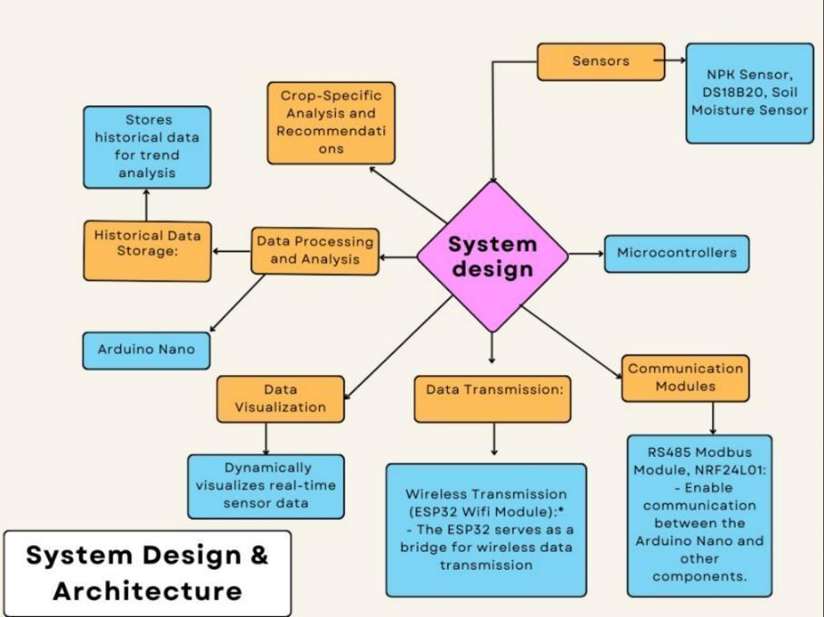

**Fig 1. System Design**

The architecture of the IoT-based Soil Health Monitoring System (fig 1) has been intricately crafted to form a cohesive framework that seamlessly integrates hardware components and software modules, facilitating real-time monitoring of soil health. The sensor network(fig 1), comprised of the NPK sensor, DS18B20, and Soil Moisture Sensor, strategically collects essential data from the soil. The RS485 Modbus Module and NRF24L01 (fig 2) ensure reliable communication between sensor nodes and the central processing unit. Acting as the system's brain, the Arduino Nano aggregates and processes the collected data before transmission.

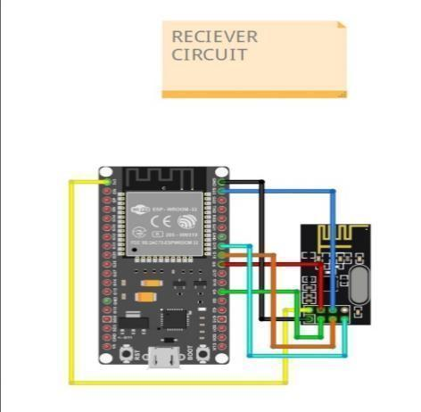 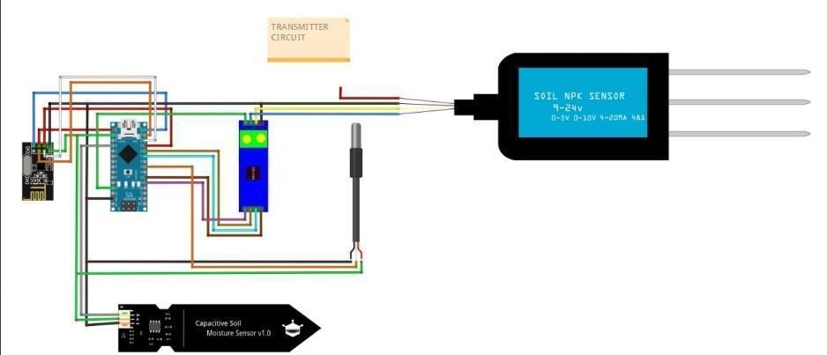

**Fig 2. Receiver Circuit Fig 3. Transmitter Circuit**

The ESP32 Wifi Module securely transmits data to the cloud server or database, establishing a connection with the web application. Developed using HTML, CSS, and JavaScript, the web application offers an intuitive interface for farmers, providing real-time visualization of soil health parameters and customization based on crop selection. Robust security measures, including user authentication and encrypted data transmission, safeguard access to personalized information. The system architecture is designed with scalability in mind, allowing for potential enhancements such as the integration of machine learning algorithms for advanced data analysis. Efficient power management mechanisms are in place to optimize energy consumption, ensuring the system's longevity.

In essence, this comprehensive architecture harmonizes hardware and software elements, empowering farmers with actionable insights for informed and sustainable agricultural practices.

Regarding the choice of the Arduino for the IoT-Based Soil Mineral Detection System, its real-time processing capabilities are highlighted, ensuring swift handling of dynamic soil sensor data crucial for timely agricultural decision-making. The simplicity of Arduino's programming environment is emphasized, proving advantageous for users with varying technical expertise and making it cost-effective for large-scale agricultural deployments. While acknowledging that Raspberry Pi could be a better alternative for projects requiring more computational power or advanced networking capabilities, the specific microcontroller design of Arduino is deemed more fitting for efficiency, responsiveness, and cost-effectiveness in the precision agriculture context.

In the context of web application design, the decision to opt for React over Angular is explained as a strategic choice rooted in various compelling reasons. React's componentbased architecture is highlighted for facilitating a modular and flexible development approach, allowing the creation of reusable UI elements that streamline the overall development process. The advantages of React's virtual DOM implementation, unidirectional data flow, extensive community support, and a vast ecosystem of libraries are outlined, emphasizing the goal of building a scalable, responsive, and maintainable web application that can adapt to evolving project requirements and industry standards.

**b) Working Principle**

The operational foundation of the IoT-Based Soil Health Monitoring System is anchored in a robust working principle that harmoniously integrates various components, empowering farmers with immediate insights into soil health. Specialized sensors, including the NPK sensor, DS18B20, and Soil Moisture Sensor, diligently gather crucial data such as nutrient levels, temperature, and moisture content. The central processing hub, Arduino Nano, plays a pivotal role in ensuring the precision and standardization of this data.

Efficient wireless communication is facilitated by the RS485 Modbus and NRF24L01 modules, enabling seamless data transmission to the web application via the ESP32 Wifi Module. The web application, easily accessible on smartphones or computers, boasts a userfriendly interface where farmers can select their specific crops. Real-time sensor data dynamically materializes in visual form, providing instant insights into NPK levels, soil moisture, and temperature. This information is then compared against crop-specific nutrient requirements, offering farmers clear indications of prevailing soil conditions.

The system's prowess extends to historical data analysis, empowering farmers to identify trends over time. An alert mechanism further enhances proactive decision-making by notifying farmers of extreme conditions. To safeguard the integrity of personalized data, robust user authentication and encryption mechanisms are implemented, ensuring the confidentiality of information.

In essence, this working principle (fig 4) seamlessly integrates hardware, wireless communication, and a user-friendly interface. It serves as a catalyst for data-driven decision-making, facilitating sustainable agricultural practices by placing actionable insights directly in the hands of farmers.

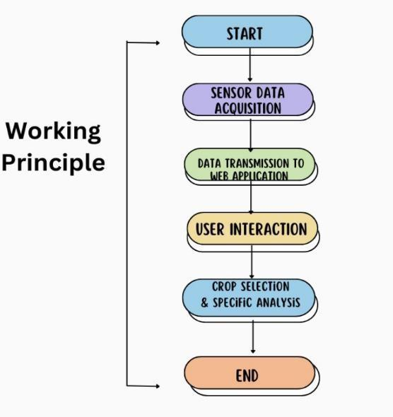

**Fig 4. Flowchart**

**c) Results and Discussion**

In the results and discussion section, the paper includes, detailing the development process of the PCB, web app frontend, and preliminary CAD model of the product. It provides insights into the methodologies employed, challenges encountered, and solutions devised during the creation of each component. From the intricacies of circuit design and layout optimization in the PCB development to the user interface design and functionality considerations in the web app frontend, we elucidate the thought processes and technical decisions that shaped our outcomes. Additionally, the paper explores the initial stages of CAD modeling, highlighting the key design considerations and iterations undertaken to achieve the desired product visualization. Through this comprehensive analysis, this paper aims to shed light on the evolution of our project's key components and the implications of the findings for future development endeavors.

## PCB Design

The preliminary PCB design for the transmitter and receiver circuit was meticulously crafted using KiCad 7.0, an open-source electronic design automation (EDA) tool known for its versatility and robust features. The design process began with the translation of our

circuit diagram into a schematic layout within KiCad, where components were meticulously placed and interconnected to reflect the functional requirements of our system.

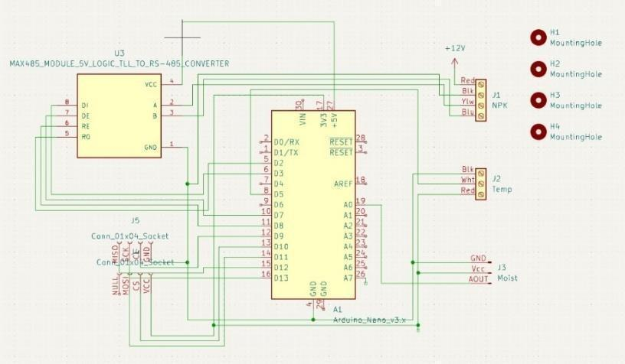

**Fig 5. PCB circuit Diagram**

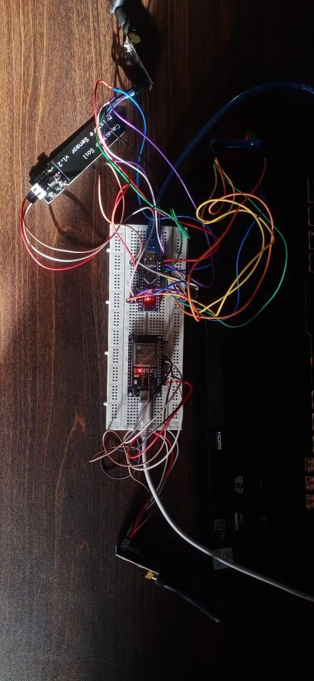

The PCB layout (fig 5) phase involved the placement of components on the board to optimize signal flow, minimize electromagnetic interference (EMI), and ensure manufacturability. Components were strategically positioned to minimize trace lengths, reduce signal coupling, and maintain signal integrity. KiCad's advanced routing capabilities allowed us to implement intricate signal paths, incorporating techniques such as differential routing and controlled impedance routing to meet the design specifications.

Careful attention is paid to power distribution and grounding strategies to minimize noise and ensure stable operation of the circuit (fig 6). Decoupling capacitors were strategically placed near power pins to suppress voltage fluctuations, while ground planes were utilized to provide a low-impedance return path for signals and reduce ground bounce.

The resulting PCB design (fig 7) reflected a balance between functionality, manufacturability, and performance. The layout was optimized to accommodate the required components while minimizing board size and cost. Signal traces were carefully routed to avoid interference and maintain signal integrity, while robust power distribution and grounding ensured reliable operation of the circuit.

Overall, the preliminary PCB design represented a significant milestone in the development of our IoT-based soil mineral detection system, laying the foundation for further testing, refinement, and optimization. With KiCad's powerful design tools and intuitive interface, we were able to realize our design objectives effectively, creating a PCB layout that meets the technical requirements of our project while adhering to best practices in PCB design.



**Fig 6. PCB Schematic Fig 7. PCB Design**

**Web Application**

In this project, which focuses on developing an e-commerce platform for agricultural products using the MERN stack, the front end assumes a central role in delivering a seamless and engaging user experience. As modern consumers increasingly demand fast, responsive, and secure online shopping environments, our front-end development efforts prioritize the utilization of React, a powerful JavaScript library known for its declarative, component-based architecture. By structuring our application into reusable UI components, we ensure modularity, maintainability, and scalability, aligning with the core principles of SPA development.

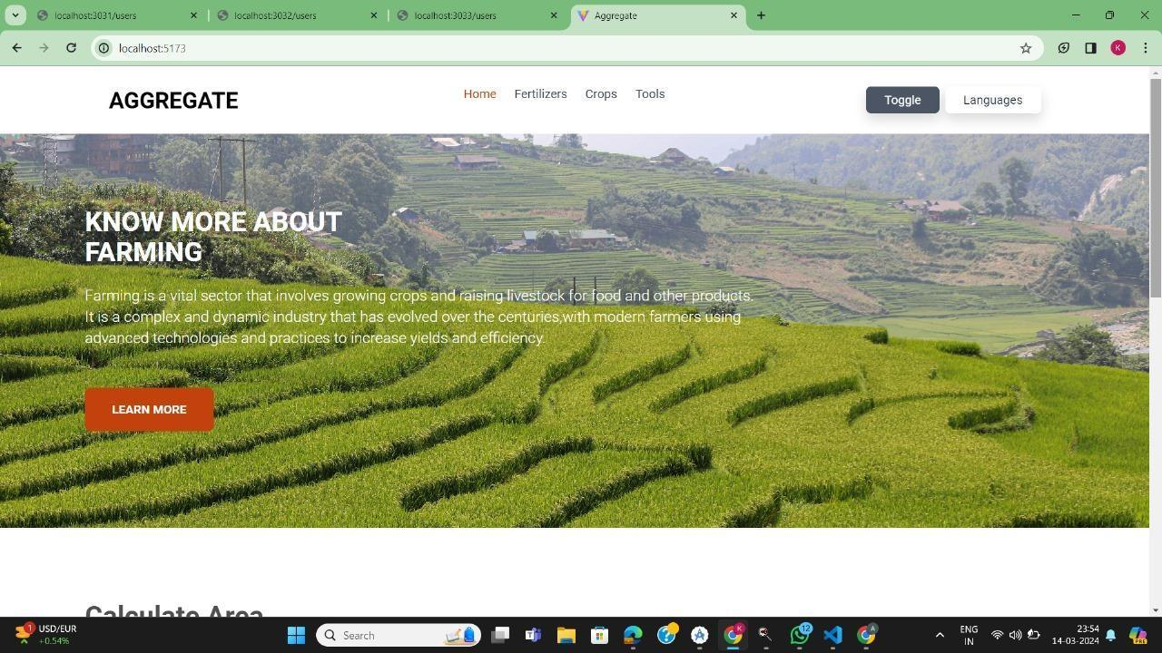

With React, we have the flexibility to create dynamic user interfaces that respond to user interactions in real-time, facilitating features such as browsing products, adding items to the cart, and completing purchases. As users navigate through our e-commerce platform, React's virtual DOM and reconciliation algorithm optimize performance by minimizing DOM manipulation and re-rendering, ensuring a smooth and fluid user experience. This is particularly crucial in the context of our agricultural e-commerce platform, where users expect quick and intuitive access to a wide range of products and information.

Furthermore, React Router enables seamless navigation between different views or pages within our application, enhancing usability and facilitating efficient user workflows. By defining routes as components and rendering them based on the current URL, we simplify navigation logic and ensure consistency in the user experience across various parts of our platform. This navigational structure is essential for guiding users through the process of exploring products, managing their cart, and completing transactions, thereby enhancing the overall shopping experience.

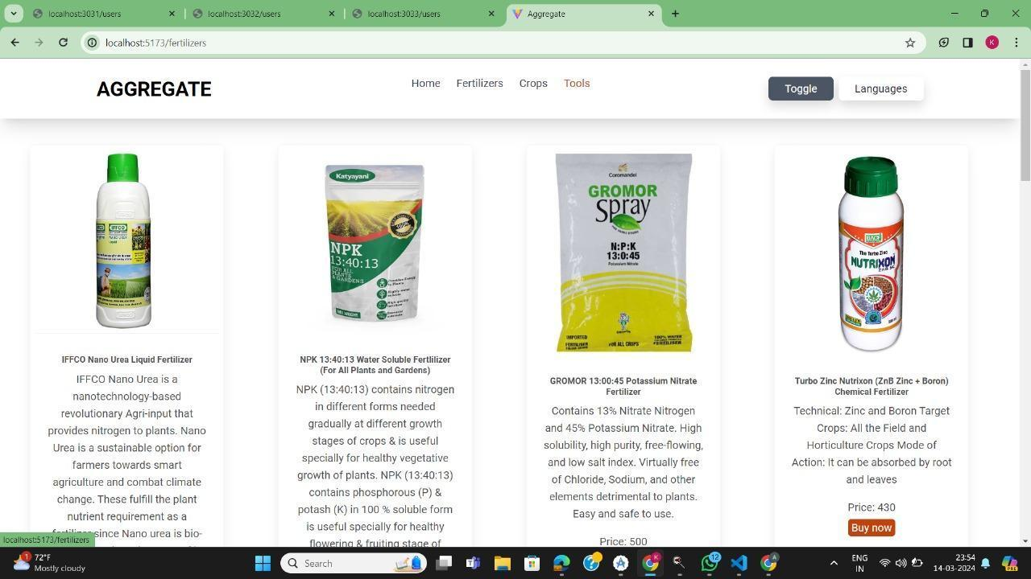

In terms of state management, the front-end development efforts leverage Redux, a popular state management library in the React ecosystem. With Redux, we centralize and manage application state in a predictable and scalable manner, ensuring consistency across different components and facilitating data synchronization between the front end and the backend. This centralized approach to state management is particularly beneficial for our agricultural e-commerce platform, where users may interact with various parts of the application concurrently, such as browsing products while managing their cart or updating their user profile.

Moreover, the front-end development strategy prioritizes optimization and performance to deliver a fast and responsive user experience. Techniques such as code splitting, lazy loading, and memoization are employed to reduce bundle size, minimize initial load times, and improve runtime performance. This optimization is crucial for meeting the expectations of modern consumers who demand instantaneous access to product information and seamless interaction with our platform.

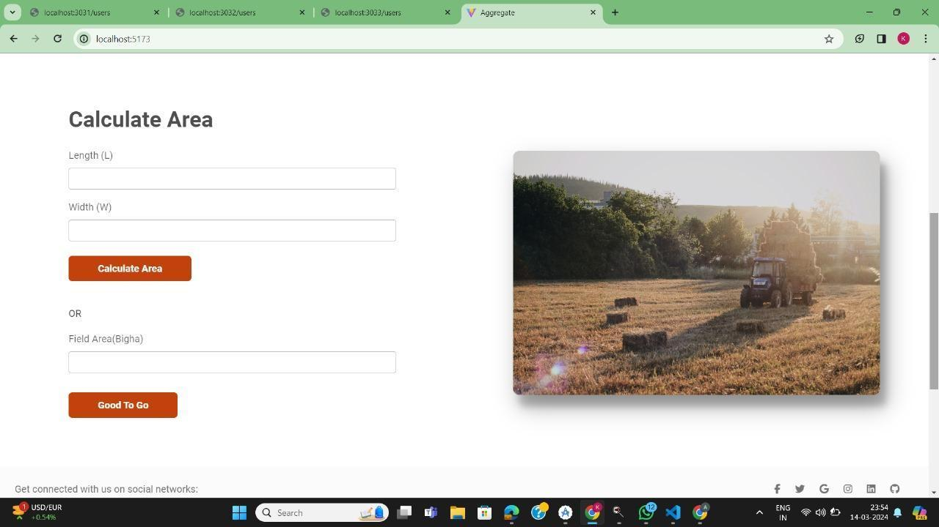

In terms of accessibility and SEO, the front-end development efforts adhere to best practices to ensure that our agricultural e-commerce platform is inclusive and discoverable. Semantic HTML, ARIA roles, and focus management techniques are utilized to enhance accessibility for users with disabilities and assistive technologies. Additionally, server-side rendering (SSR) and pre-rendering techniques are employed to improve crawlability and indexability by search engines, enhancing the discoverability of our platform and driving organic traffic.

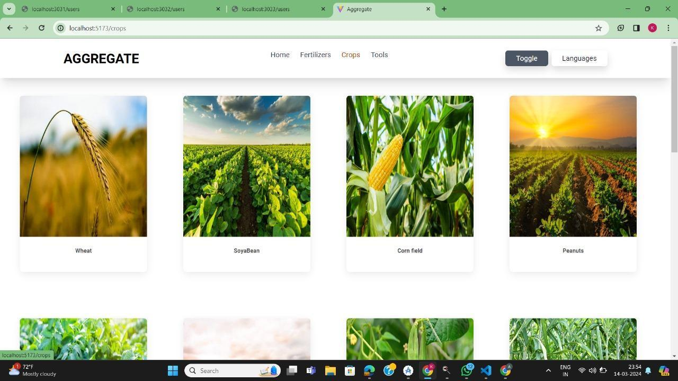

In summary, the front-end development of our agricultural e-commerce platform using the MERN stack is characterized by a focus on delivering a fast, responsive, and engaging user experience. Through the utilization of React, Redux, and related technologies, we aim to create a dynamic and intuitive platform that meets the needs of modern consumers while adhering to best practices in optimization, accessibility, and SEO. By prioritizing the frontend experience, we seek to differentiate our platform in the competitive e-commerce landscape and provide value to users in the agricultural sector.

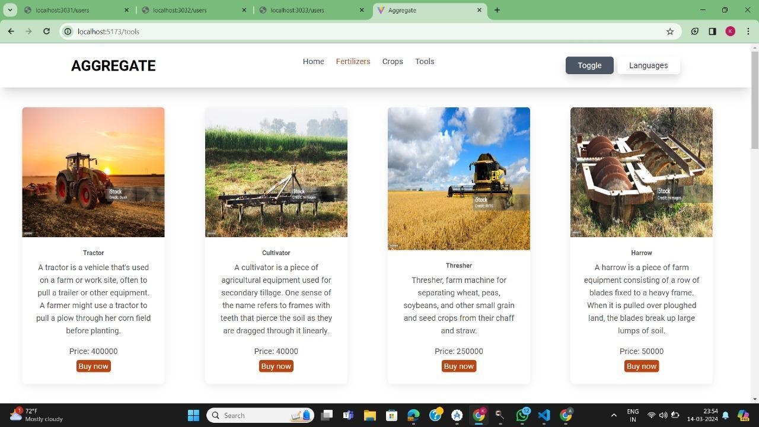

**d) Methodology:**

This section discusses the approaches involved in the development of the CAD model, as well as the 3D printing materials that were used. The design process prioritizes functionality, user-friendliness, and weatherproofing for field applications.

**Material used:**

PLA is a biodegradable thermoplastic derived from renewable resources such as corn starch or sugarcane. Its eco-friendliness, ease of use, and mechanical properties make it a suitable choice for manufacturing casings for electronic devices. PLA material was chosen for the IoT device casing for several reasons:

Biodegradability: PLA is biodegradable, making it an environmentally friendly option compared to traditional petroleum-based plastics. This aligns with the growing emphasis on sustainability in product design and manufacturing.

Ease of Processing: PLA can be easily processed using methods such as 3D printing and injection molding. This facilitates rapid prototyping and customization of casings to meet specific design requirements.

Mechanical Properties: PLA offers sufficient mechanical strength and rigidity to protect electronic components housed within the casing. It provides adequate impact resistance while maintaining a lightweight profile, which is essential for portable IoT devices.

Cost-effectiveness: PLA is relatively affordable compared to other engineering plastics, making it a cost-effective choice for small to medium-scale production runs.

The design process involved utilizing SolidWorks, a computer-aided design (CAD) software, to create a detailed model of the IoT device casing. The following steps were undertaken:

Initial Conceptualization: The design requirements, including dimensions, functionality, and aesthetic considerations, were defined. Sketches and rough drawings were created to conceptualize the casing design.

Incorporation of PCB and Battery Dimensions: The dimensions of the PCB and battery were obtained, and the casing design was modified to accommodate these components securely. This ensured proper alignment and fitment of electronic elements within the casing.

2D Diagram Creation: A detailed 2D diagram with precise dimensions was generated to illustrate the specifications of the casing design. This diagram serves as a reference for manufacturing and assembly processes.

Iterative Refinement: The initial design underwent iterative refinement based on feedback and analysis results. Structural integrity, ease of assembly, and ergonomic factors were evaluated to optimize the casing design.

The CAD model (fig 8) of the IoT device casing was developed using SolidWorks, incorporating the dimensions of the PCB and battery. The design features a sleek and compact form factor with provisions for component mounting and cable routing. The casing is divided into compartments to segregate different electronic modules and ensure efficient heat dissipation.

The selection of PLA was based on its biodegradability, ease of processing, mechanical properties, and cost-effectiveness. The design process, conducted using SolidWorks, ensured the integration of PCB and battery dimensions into the casing design, resulting in a functional and aesthetically pleasing product. Moving forward, further testing and validation will be conducted to assess the performance and durability of the PLA-based casing in real-world applications.

**Design Considerations:**

The CAD model will incorporate the following key aspects:

Dimensions: The overall dimensions of the housing are determined based on the size and number of selected sensors, the microcontroller, and the battery pack. The design ensures adequate space for each component while maintaining a compact and portable form factor.

Sensor Compartments: Dedicated compartments are designed for each sensor, ensuring proper placement and secure attachment. This involved creating individual housings for the soil moisture sensor, soil temperature probe, and potentially the NPK sensor (if included). Each compartment should allow for easy access to the sensors for calibration or maintenance purposes.

Ventilation: Strategically placed ventilation holes are incorporated throughout the housing to prevent moisture buildup within the electronics compartment. The design ensures adequate airflow without compromising weatherproofing.

Weatherproofing: The housing exterior is designed with a sloped roof to facilitate water runoff and minimize water accumulation. Drainage features, such as small channels or openings at the base, are added to further prevent water ingress.

Mounting Mechanism: The design includes a dedicated mounting mechanism for secure placement of the system in the field. This could be a stake that attaches to the bottom of the housing, allowing for direct insertion into the soil. Alternatively, a bracket system could be designed for attaching the housing to existing fences or posts.

Ease of Assembly: The housing is designed with a modular approach, allowing for disassembly and reassembly for maintenance purposes. This may involve incorporating snap-fit features or screw connections for easy access to the internal components.



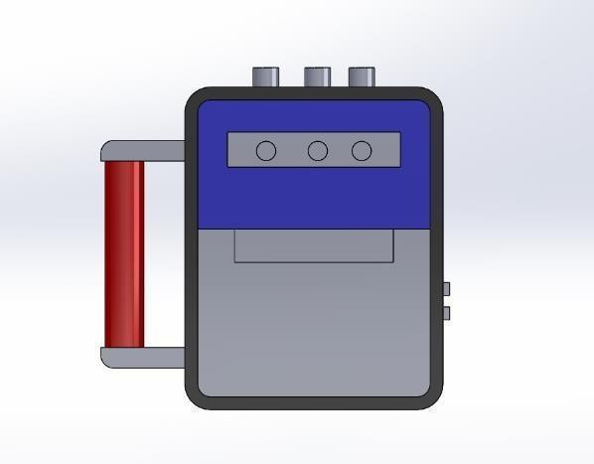

**Fig 8. Preliminary CAD model**

**Design Process**

Conceptual Design: Initial sketches and 2D drawings are created to establish the overall layout and dimensions of the housing, considering the placement of sensors, electronics, and ventilation features.

3D Modelling: Using Solidworks, a 3D model of the housing is created. This model incorporates all the design considerations mentioned above, including sensor compartments, ventilation holes, and the mounting mechanism.

Detailed Design: The 3D model is further refined to include chamfers and fillets for improved printability and structural integrity,lid design for the electronics compartment, ensuring easy access while maintaining a secure closure, Cable management features, such as slots or channels, to organize and protect internal wiring.

Assembly Modelling: A virtual assembly of the model is conducted within the CAD software to ensure proper fit and functionality between all components (housing parts, sensors, electronics). This allows for the identification and correction of any potential design flaws before printing.

Design Verification and Iteration: The 3D model is thoroughly reviewed to confirm it meets all the design requirements. This may involve performing virtual simulations to assess factors like strength and water resistance. The design is iterated upon based on the verification results to optimize its functionality.

3D Printing File Generation: Once finalized, the 3D model is exported in a format suitable for 3D printing, such as STL (Standard Tessellation Language). This file is used to print the physical housing on a 3D printer.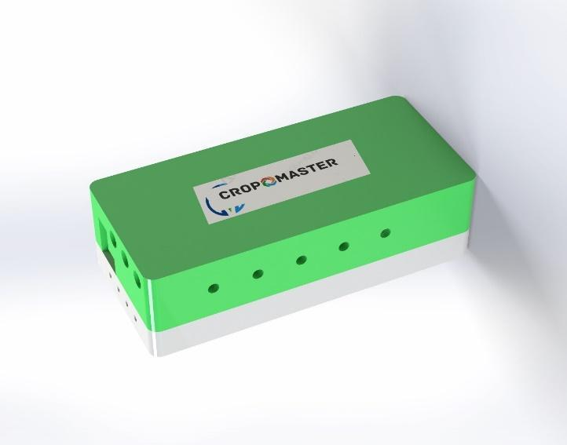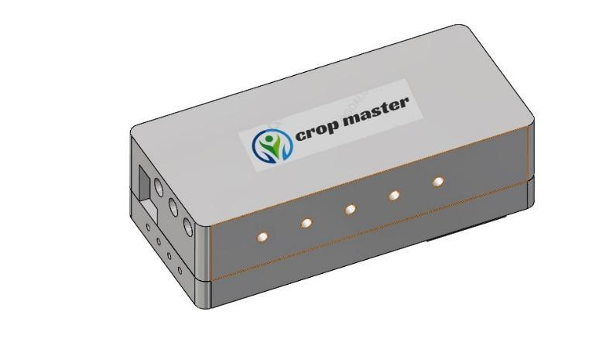



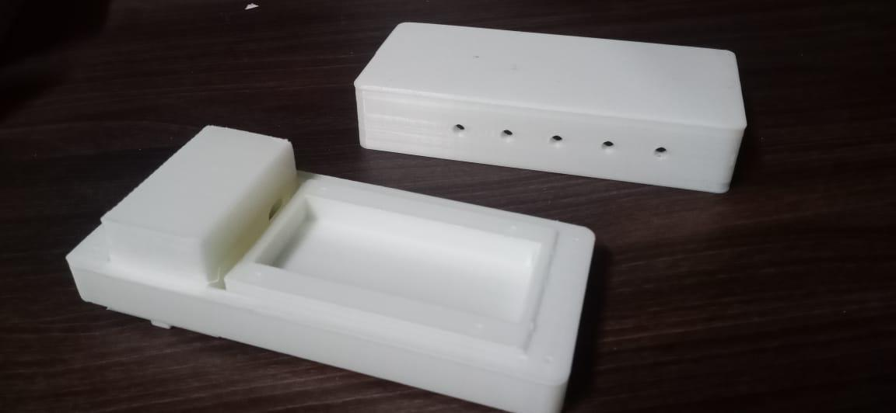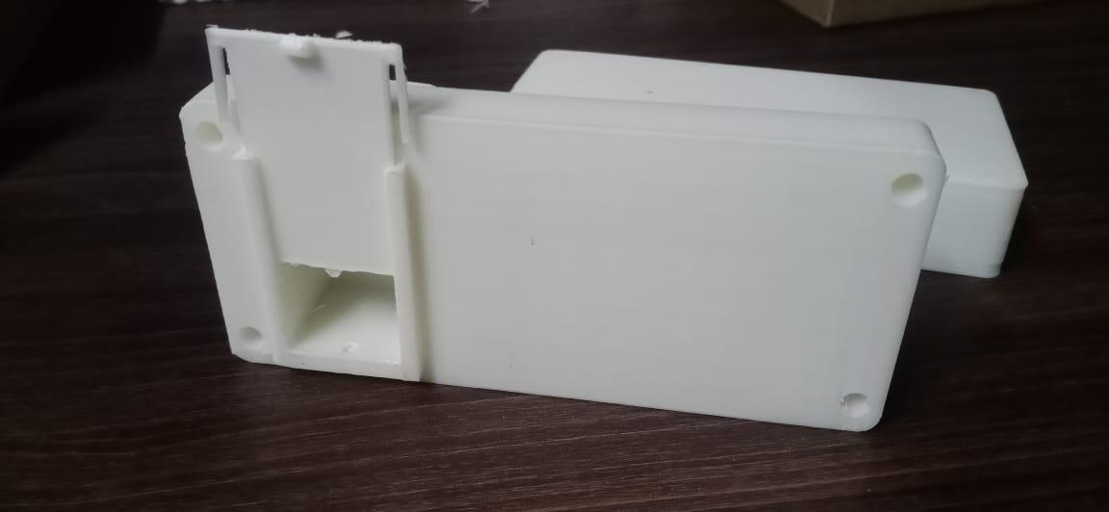

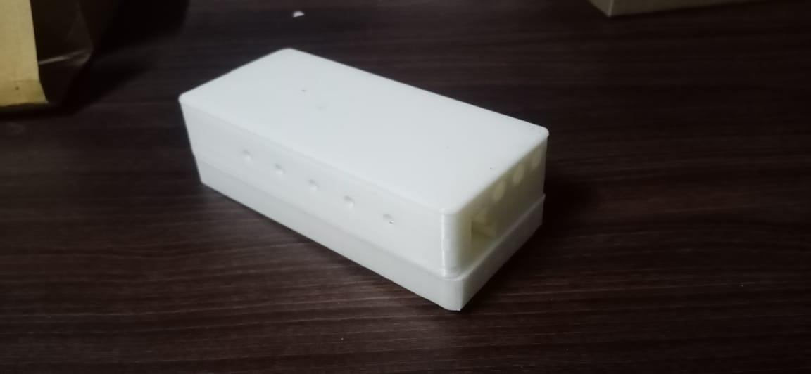



# CONCLUSION

With the achieved milestones in the front-end development of the web application and the successful creation of the PCB along with the preliminary CAD model , it is crucial to recognize the substantial tasks that await for the full realization of the IoT-Based Soil Health Monitoring System. Current focus pivots towards the back-end development of the web application, where it is required to establish a robust server infrastructure, construct a seamlessly functioning database, and integrate APIs to ensure smooth data transmission between the sensors and the application.

Anticipation is building around the imminent development of critical components, including the historical data tracking feature, the alert system, and the comprehensive testing of the entire system. The historical data tracking feature will empower farmers to observe trends in soil health parameters over time, significantly contributing to informed decision-making. The alert system, when implemented, will play a pivotal role in notifying farmers of extreme conditions, facilitating timely interventions. Rigorous testing of the entire system ensures that all components seamlessly interact, delivering accurate and reliable results across diverse conditions.

Security measures, such as user authentication and encrypted data transmission, are prioritized, reflecting our commitment to ensuring the confidentiality and integrity of the system. An iterative process of gathering user feedback and making continuous improvements will be a hallmark of the system's development, ensuring alignment with the practical needs and experiences of its endusers.

While acknowledging the work that lies ahead, the team assures stakeholders of their dedication to addressing these tasks with diligence and precision. The expectation is that, with continued efforts and collaboration, the IoT-Based Soil Health Monitoring System will be completed in a timely manner. It is anticipated that this system will play a significant role in advancing precision agriculture practices, ultimately benefiting farmers in their day-to-day decision-making processes.

# Reference

1. N. Ananthi, J. Divya, M. Divya and V. Janani, "IoT based smart soil monitoring system for agricultural production," 2017 IEEE Technological Innovations in ICT for Agriculture and Rural Development (TIAR), Chennai, India, 2017, pp. 209-214,

*DOI: 10.1109/TIAR.2017.8273717*.

1. Sandeep V. Gaikwad, Amol D. Vibhute, Karbhari V. Kale, Suresh C. Mehrotra, An innovative

IoT based system for precision farming,Computers and Electronics in Agriculture,Volume

187,2021,106291,ISSN 0168-1699,

*DOI:10.1016/j.compag.2021.106291*

1. B. M., Zerihun, Olwal, T. O., & Hassen, M. R. (2022). "Design and Analysis of IoT-Based Modern Agriculture Monitoring System for Real-Time Data Collection." In Algorithms for Intelligent Systems (AIS). Springer.

*DOI:10.1007/978-3-030-93107-3_14*

1. R. Reshma, V. Sathiyavathi, T. Sindhu, K. Selvakumar and L. SaiRamesh, "IoT based Classification Techniques for Soil Content Analysis and Crop Yield Prediction," 2020 Fourth

International Conference on I-SMAC (IoT in Social, Mobile, Analytics and Cloud) (I-SMAC), Palladam, India, 2020, pp. 156-160,

*DOI: 10.1109/I-SMAC49090.2020.9243600.*

1. S. Kavileswarapu, M. A. A. Khader, S. Ahmed and R. Radha, "IoT Based Smart Crop Recommendation Using Macro Nutrient Analysis of Soil," 2022 Seventh International Conference on Parallel, Distributed and Grid Computing (PDGC), Solan, Himachal Pradesh, India, 2022, pp.

501-506*,*

*DOI: 10.1109/PDGC56933.2022.10053187.*

1. S. R. J. Ramson et al., "A Self-Powered, Real-Time, LoRaWAN IoT-Based Soil Health Monitoring System," in IEEE Internet of Things Journal, vol. 8, no. 11, pp. 9278-9293, 1 June1, 2021,

*DOI : 10.1109/JIOT.2021.3056586.*

1. Kussul, N.; Lavreniuk, M.; Skakun, S.; Shelestov, A. Deep Learning Classification of Land Cover and Crop Types Using Remote Sensing Data. IEEE Geosci. Remote Sens. Lett. 2017, 14, 778–782. *DOI:*[*10.1109/LGRS.2017.2681128*](https://doi.org/10.1109/LGRS.2017.2681128)

1. Dagar, R.; Som, S.; Khatri, S.K. Smart farming–IoT in agriculture. In Proceedings of the 2018 International Conference on Inventive Research in Computing Applications (ICIRCA), Coimbatore, India, 11–12 July 2018*.*

*DOI*[*:10.1109/ICIRCA.2018.8597264*](https://doi.org/10.1109/ICIRCA.2018.8597264)

1. Hu, C.; Zhong, X.; Xu, J. Study on integrated discovery system of sensors for agriculture observation application. In Proceedings of the 2014 The Third International Conference on AgroGeoinformatics,Beijing,China,11–14August2014;

*DOI* [*:10.1109/AGRO-GEOINFORMATICS.2014.6910641*](https://doi.org/10.1109/AGRO-GEOINFORMATICS.2014.6910641)

1. Madhumathi, R.; Arumuganathan, T.; Shruthi, R. Soil NPK and Moisture analysis using Wireless Sensor Networks. In Proceedings of the 2020 11th International Conference on Computing, Communication and Networking Technologies (ICCCNT), Kharagpur, India, 1–3 July 2020.

*DOI*[*:10.1109/ICCCNT49239.2020.9225547*](http://dx.doi.org/10.1109/ICCCNT49239.2020.9225547)

1. Sangeetha, A.; Sarah Prisella, P.; Poovarasi, G.; Subramani, K. IoT based hybrid system for precision agriculture monitoring using WSN into modern information and communication technology(ICT). IJARIIE 2018, 4, 2395–4396

*DOI: 16.0415/IJARIIE-7887*

1. Gosai, D.; Raval, C.; Nayak, R.; Jayswal, H.; Patel, A. Crop Recommendation System using Machine Learning. Int. J. Sci. Res. Comput. Sci. Eng. Inf. Technol. 2021, 7, 554–557.

*DOI:*[*10.32628/CSEIT2173129*](https://doi.org/10.32628/CSEIT2173129)

1. Gupta, S.; Geetha, A.; Sankaran, K.S.; Zamani, A.S.; Ritonga, M.; Raj, R.; Ray, S.; Mohammed, H.S. Machine Learning- and Feature Selection-Enabled Framework for Accurate Crop Yield Prediction. J. Food Qual. 2022, 2022, 6293985.

*DOI:* [*10.1155/2022/6293985*](https://doi.org/10.1155/2022/6293985)

1. Suchithra, M.; Pai, M.L. Improving the prediction accuracy of soil nutrient classification by optimizing extreme learning machine parameters. Inf. Process. Agric. 2020, 7, 72–82. *DOI:*[*10.1016/j.inpa.2019.05.003*](http://dx.doi.org/10.1016/j.inpa.2019.05.003)

1. Reshma, R.; Sathiyavathi, V.; Sindhu, T.; Selvakumar, K.; SaiRamesh, L. IoT based Classification Techniques for Soil Content Analysis and Crop Yield Prediction. In Proceedings of the 2020 Fourth International Conference on I-SMAC (IoT in Social, Mobile, Analytics and Cloud)

(I-SMAC), Palladam, India, 7–9 October 2020;

*DOI:*[*10.1109/I-SMAC49090.2020.9243600*](http://dx.doi.org/10.1109/I-SMAC49090.2020.9243600)

1. Balakrishnan, N.; Muthukumarasamy, G. Crop production-ensemble machine learning model for prediction. Int. J. Comput. Sci. Softw. Eng. 2016, 5, 148.

*DOI:* [*10.1016/j.eaef.2019.11.003*](https://doi.org/10.1016/j.eaef.2019.11.003)

1. Sivakumar, R.; Prabadevi, B.; Velvizhi, G.; Muthuraja, S.; Kathiravan, S.; Biswajita, M.; Madhumathi, A. Internet of Things and Machine Learning Applications for Smart Precision Agriculture. In IoT Applications Computing; IntechOpen: London, UK, 2022; p. 135. *DOI: 10.5772/intechopen.97679*

1. Kulkarni, N.H.; Srinivasan, G.N.; Sagar, B.M.; Cauvery, N.K. Improving crop productivity through a crop recommendation system using ensembling technique. In Proceedings of the 2018 3rd International Conference on Computational Systems and Information Technology for Sustainable Solutions (CSITSS), Bengaluru, India, 20–22 December 2018.

*DOI:*[*10.1109/CSITSS.2018.8768790*](https://doi.org/10.1109/CSITSS.2018.8768790)

1. Akhter, R.; Sofi, S.A. Precision agriculture using IoT data analytics and machine learning. J.

King Saud Univ.-Comput. Inf. Sci. 2021, 34, 5602–5618

*DOI:* [*10.1016/j.jksuci.2021.05.013*](https://doi.org/10.1016/j.jksuci.2021.05.013)

1. AshifuddinMondal, M.; Rehena, Z. IoT based intelligent agriculture field monitoring system.

In Proceedings of the 2018 8th International Conference on Cloud Computing, Data Science &

Engineering (Confluence), Noida, India, 11–12 January 2018;

*DOI:*[*10.1109/CONFLUENCE.2018.8442535*](http://dx.doi.org/10.1109/CONFLUENCE.2018.8442535)

1. Khaki, S.; Wang, L. Crop Yield Prediction Using Deep Neural Networks. Front. Plant Sci. 2019, 10, 621

*DOI :* [*10.3389/fpls.2019.00621*](https://doi.org/10.3389/fpls.2019.00621)

1. Viviliya, B.; Vaidhehi, V. The Design of Hybrid Crop Recommendation System using Machine Learning Algorithms. Int. J. Innov. Technol. Explor. Eng. (IJITEE) 2019, 9, 4305–4311. *DOI: 10.35940/ijitee.B7219.129219*

1. Prabhu, S.; Revandekar, P.; Shirdhankar, S.; Paygude, S. Soil analysis and crop prediction. Int. J. Sci. Res. Sci. Technol. 2020, 7, 117–123.

*DOI:*[*10.32628/IJSRST207433*](http://dx.doi.org/10.32628/IJSRST207433)

1. Schwalbert, R.A.; Amado, T.; Corassa, G.; Pott, L.P.; Prasad, P.; Ciampitti, I.A. Satellite-based soybean yield forecast: Integrating machine learning and weather data for improving crop yield prediction in southern Brazil. Agric. For. Meteorol

*DOI:*[10.1016/j.agrformet.2019.107886](http://dx.doi.org/10.1016/j.agrformet.2019.107886)

1. Nawandar, N.K.; Satpute, V. IoT based intelligent irrigation support system for smart farming

applications. ADCAIJ Adv. Distrib. Comput. Artif. Intell. J. 2019, 8, 75–85

*DOI:* [*10.14201/ADCAIJ2019827585*](https://doi.org/10.14201/ADCAIJ2019827585)

1. Kumar Santosh Shukla Shivam Dubey Tarun Rastogi Application using MERN Stack June 2022International Journal for Modern Trends in Science and Technology 8(6):102-105 *DOI:10.46501/IJMTST0806014*

1. Sanjivani Bagade1, Megha Bhatt2, Shital Gondhali3, Prof. Vilas Jadhav4 1,2,3Student Farmer Portal System using MERN Stack, Dept. of Computer Engineering, M.G.M. College of Engineering and Technology, Kamothe, Maharashtra, India

1. : Dr. B Jalendar, K Nagaraju, Md Abdul Qadir, Md Khaja Naseeruddin Bhaba, S Ajay

FARMASITE: A Web Application Portal Designed for Farmers

*DOI:* [*10.22214/ijraset.2023.55460*](https://doi.org/10.22214/ijraset.2023.55460)

1. Basappa Karlatthe MERN Stack Based User Authentication Technique for Evernote Application November 2023INTERANTIONAL JOURNAL OF SCIENTIFIC RESEARCH IN ENGINEERING AND MANAGEMENT 07(11):1-11  *DOI:*[*10.55041/IJSREM27053*](http://dx.doi.org/10.55041/IJSREM27053)

1. Work Management Tool based on PHP and HTML Ghimire, Bikash (2020)

